R Noah Padilla
CS 4363
2/12/2021
Lab 2 Report

Problem description
For this lab I had to implement a technique called lucky imaging, which is very commonly used in astronomy. Three datasets were provided, each containing 1000 low-quality astronomical images. My goal was to produce the best possible image combining the individual images in each dataset. I had to experiment with the below steps to produce the best possible image for each data set:
1. Compute average image in dataset (provided)
2. Align images in dataset
3. Select only the best images in dataset
4. Perform intensity transformations (gamma, log, sigmoid, histogram equalization)
Algorithm Implemented
The algorithm I implemented for this lab to produce the best possible image for each o f the data sets –
1. Calculate the average image
2. Find the brightest region of the average image and get its top left coordinate
3. Get the best (stars are denser than distributed for a region) images from the data set
- Calculate and store the brightest region for each image into an array
- Sort the region sums
- Get the last 10% indices from of the array
4. Align the top 10% images by shifting them until their top left coordinate is the same as the top left average brightest region coordinate
5. Produce the best unfiltered image by averaging those top images excluding the
average image
6. Produced the best image by experimenting with the each of the filters

Experiments
Since the algorithm for obtaining the best unfiltered image was linear (shown by steps 1-5 of the algorithm), I mainly experimented when choosing the best filter. The first part of the algorithm was linear because selecting the best unfiltered image seemed trivial with advice from class. Although, the best unfiltered image seemed to be trivially found, finding the best filtered image to enhance the image further did require some testing. The filters that I used are shown and described below –
- Gamma filter – under or over exposes an image > changes brightness
- Log filter – overexposes an image more smoothly > brighten image more smoothly
- Sigmoid filter – moves intensities towards their extremes > lights get lighter and darks get darker
- Adaptive Equalization filter - gets a region of the image around a pixel, equalizes the intensities in that region, then transforms that pixel based off those intensities > show finer details better
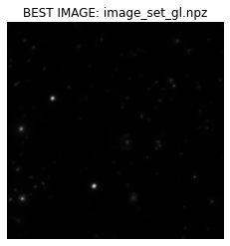
The best unfiltered images are shown below –

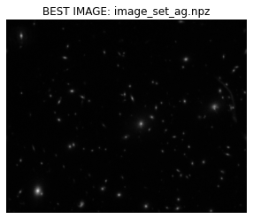

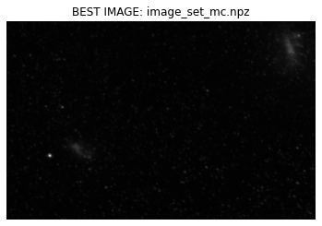

I applied each filter to the datasets best unfiltered image then decided to further experiment with the filters that enhanced image quality (brightens stars) the best from the previous filters. The results are shown below for the first, second and third dataset respectively –

Image set 1 – image_set_gl.npz
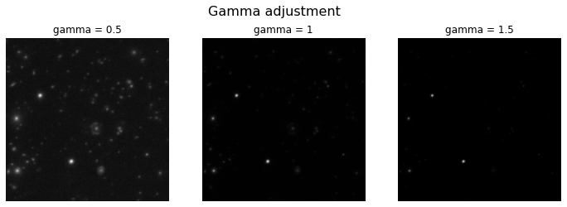
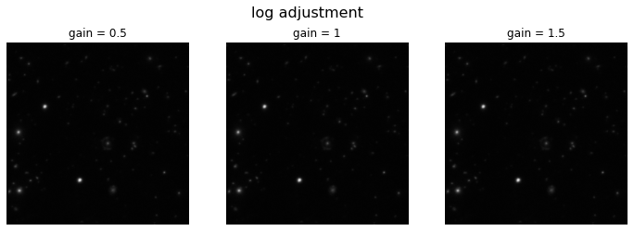
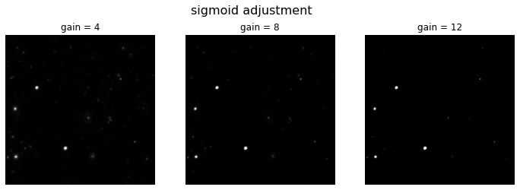
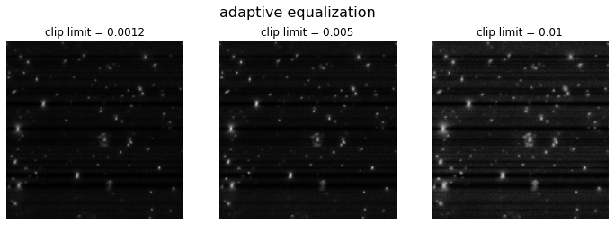

Image set 2 – image_set_ag.npz

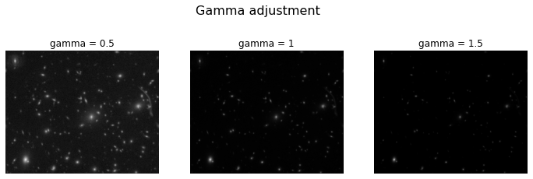

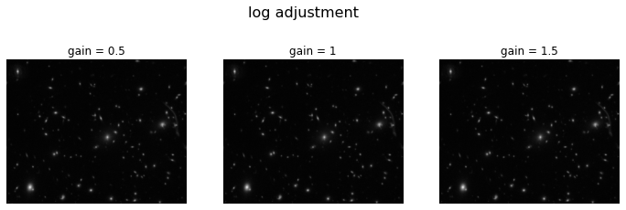
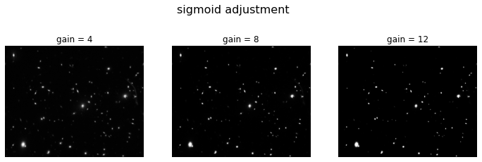
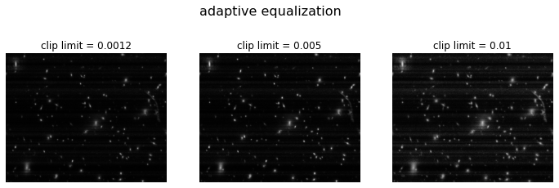

Image set 3 – image_set_mc.npz

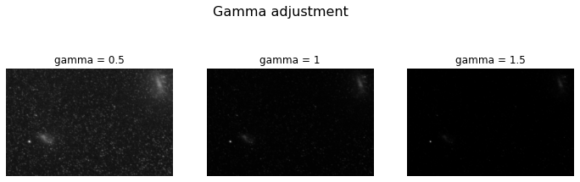

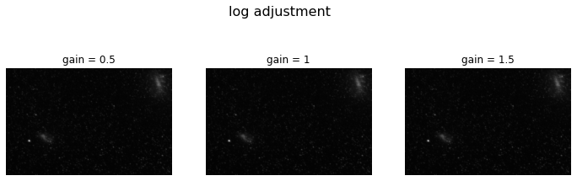

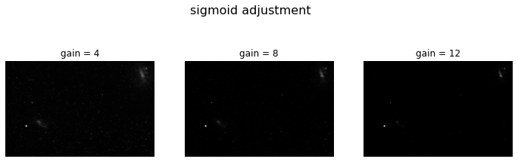
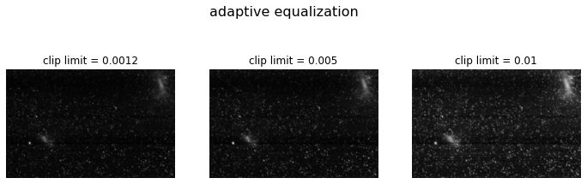

Further experimentation

After choosing predetermined values for each filter in the previous experiments, I determined that the sigmoid and gamma function yielded good results for gain=.5 and gain=4 respectively. I decided to further experiment with gamma by decreasing their values. The results for the gamma and sigmoid for the first, second and third datasets respectively are shown below–
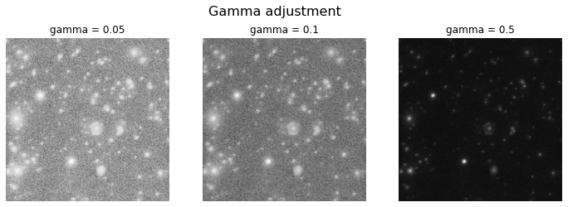
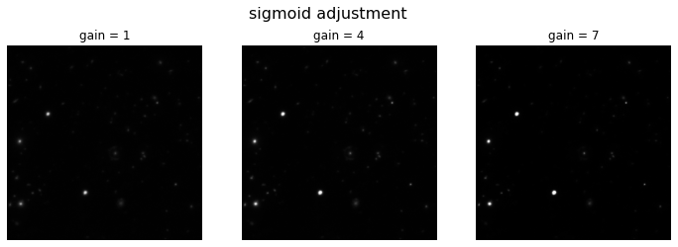

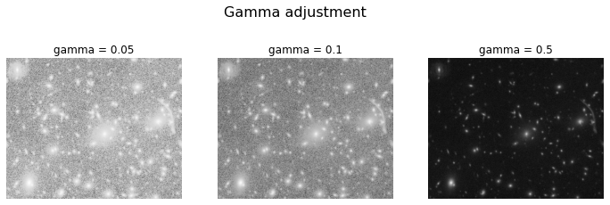
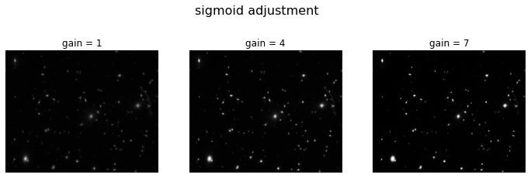
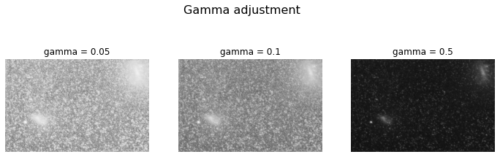
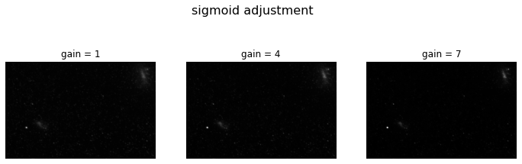

This concludes my experimentation for image enhancement.

Conclusions
In conclusion, after all this experimentation for image enhancement, the gamma filter yielded the best results with gamma=.5 due to its effect in exposing stars that could not be seen from the respective best unfiltered images. What I learned from this assignment was that image enhancement does not only associate with filters but can also associate with obtaining a finer image from previous images- in this case it was parts 1-5 of the algorithm that was implemented in this lab.

APPENDIX

